Sprint Retrospective – 28.04

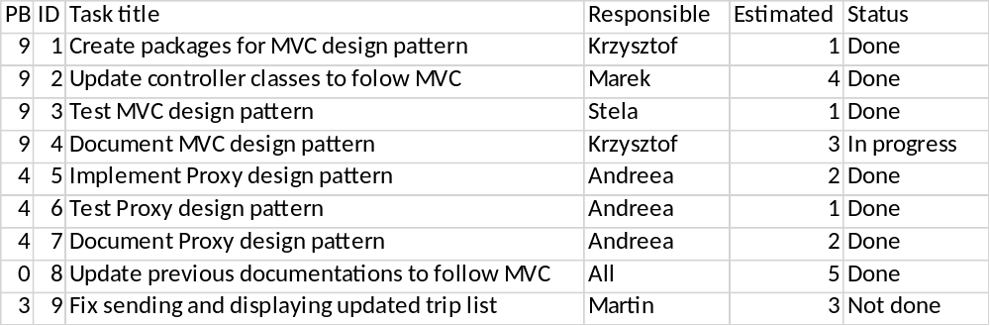

In this sprint we have created packages for MVC design pattern. We had to rewrite a lot of code which we have copied from SEP1 and was not following MVC rules. After that we tested MVC by applying rules on our pattern and trying to find any mistakes. Documentation for MVC was not finished however. Andreea also implemented a proxy design pattern, which was tested and documented afterwards. All previously made documentations were updated to follow new code or packages. We have planned to fix sending and displaying trips in GUI but we didn’t manage to complete this task.

